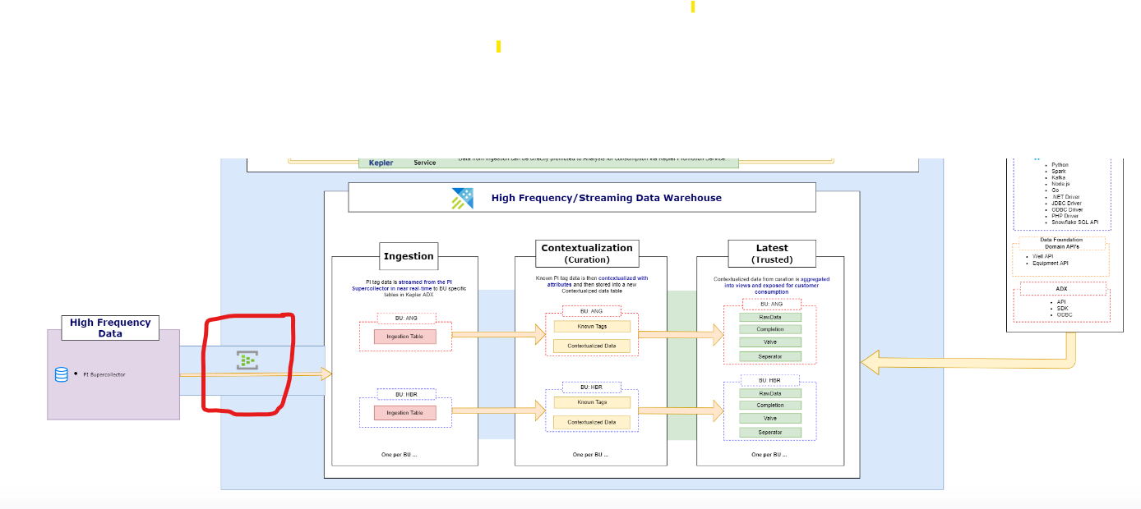

(Izan) Rohaizan Modh Norddin

Hi Izan,

I am from MDL Team, and we do have a POC work, where we need to pull some data from the Azure Event Hub marked in the Red Color above.

So, we need some information about the Azure Event Hub Credential and connection Details. So, Could you please guide us to any Point of contact on this to connect and discuss more on this.

<https://portal.kepler.xom.cloud/architecture>